Project Name: Automate a Web Application.

GitHub Link:

## <https://github.com/tamasjit/myjavaproject/tree/master/Phase%205/Phase-5_Practice_Project/q1_Automate_a_Web_Application>

## Output:

### Registration Process:

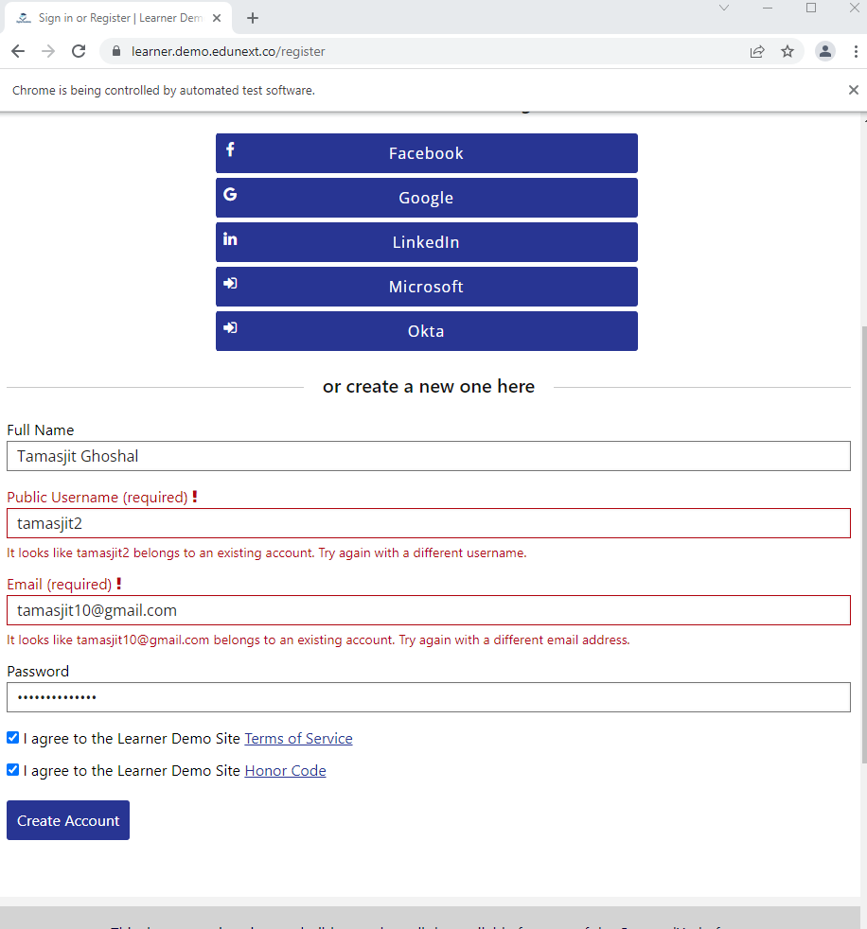

### Dashboard:

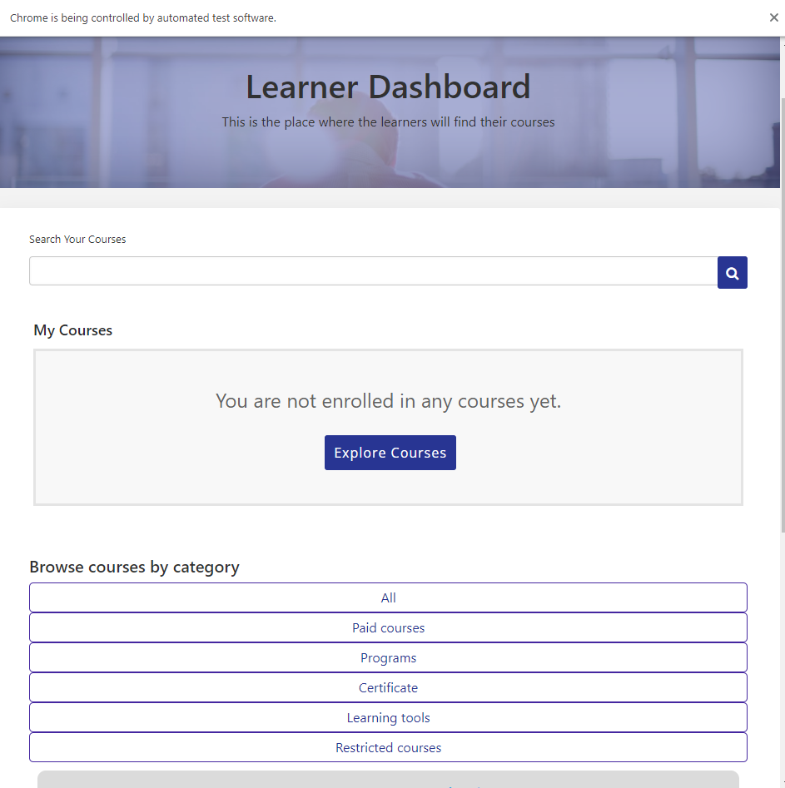

### Login Process:

